Day 1

Subject Lines:
NEW Proven Way to Burn Fat in 4 Minutes
4-Minute Trick to Bust a Plateau
Re: New Density Workout

It was a warm Spring morning and Philip had just smoked another metabolic workout with Mike Whitfield, his trainer that had lost 105 pounds himself.

At the end of each session, Philip would work with Mike on some intense conditioning, also known as a metabolic finisher. This was Mike’s “secret ingredient” to his client’s success in losing 34 pounds in just 12 weeks.

These finishers would only last a few minutes (as little as 3 minutes), but because they are so powerful, his clients never hit a plateau and kept burning pounds of fat each and every week.

Mike Whitfield, the creator of the new Bodyweight Metabolic Finishers system, uses these zero-equipment finishers with his clients at the end of each workout, but they also use these as off day conditioning workouts.

In fact, Mike creates his finishers that are so effective, that he has had 6 clients place or win in the Turbulence Training Transformation contests without ANY cardio. His clients love them and that’s why they’ve been able to stay with their workouts so consistently.

These bodyweight finishers can be done anywhere, and are proven to melt fat, no matter what workout program you might be on. You just simply tag these on at the end of your workouts.

And right now, you can get a whopping 39 bodyweight finishers for just $20, which is just 52 cents for a program proven to work, helping thousands already.

=> New Bodyweight Finishers (use with YOUR program)

You may find it hard to believe, but you can bust a weight loss plateau and SPEED up your weight loss dramatically, just like Mike’s clients in just 10 minutes or less.

In fact, look at what this study revealed:

Canadian researchers at Queen's University tested a Bodyweight Finisher style workout against long cardio. (Reference: Appl Physiol Nutr Metab. 2012 Sep 20.)
22 college-aged women did 4 workouts per week for 4 weeks in one of three groups.
Group A did 30 minutes of treadmill running at 85% max heart rate

Group B did 8 rounds of 20 seconds of a single bodyweight exercise (burpees, jumping jacks, mountain climbers, or squat thrusts) with 10 seconds of rest between rounds.

Group C did nothing (they were the non-training control group).
Results:
Both training groups increased their aerobic fitness levels by the SAME amount (about 7-8%). That's right, the short bodyweight workouts (of 4 minutes) worked just as well as 30 minutes of cardio. Shocking.

BUT...only Group B, the Bodyweight Finishers style training, also increased muscular endurance in common exercises like chest presses, leg extensions, sit-ups, and push-ups.

And finally, the Bodyweight Finishers training used by Group B also resulted in greater overall workout enjoyment.

The Canadian Scientists concluded that "extremely low volume bodyweight interval-style training" will boost cardiovascular fitness just as well as cardio while giving you BETTER improvements in muscle endurance...
...All in just 4 minutes
=> There is a 4-minute finisher on this very page you can try

You’ll see why Mike’s clients use this trick instead of long, boring cardio. They have even given up intervals!

Fortunately, when you get your hands on PROVEN finishers (like Mike’s) to use with any workout program, you don’t have to spend more time in the gym to get results and boost your metabolism.

In fact, you won’t ever have to step on a cardio machine EVER again, just like Mike’s clients. Philip, along with 5 other clients have beaten thousands of other contestants because of this one simple 4-minute trick he uses with every workout session.

=> He has a 4-exercise metabolic finisher just for you right here

This is the amazing part – THESE bodyweight finishers require NO equipment. That means you don’t need anything, so you can do them any time or anywhere. Yes… ZERO EQUIPMENT!

Now I’ve heard of bodyweight circuits, and I’m sure you have, too. But these are certainly different. Mike uses a variety of:

Gauntlet cirucits
Density supersets and circuits
The crazy, but effective 20-10 method

and more…

Mike is a high-energy guy, and his bodyweight finishers show that. I started to sweat just looking at them on paper. Now unless you live in the good ole’ southeast state of GA, you won’t be able to experience his bodyweight finishers… until now.

You can use the exact bodyweight finishers he has used with his contest winners. Not only that, but he’s also offering his clients’ favorite style of workouts. He has written a program called “Bodyweight Switch”, in which you use strength and finisher supersets.

So, you get the benefits of metabolic workouts while shredding fat by keeping your heart rate elevated with these addicting and effective supersets.
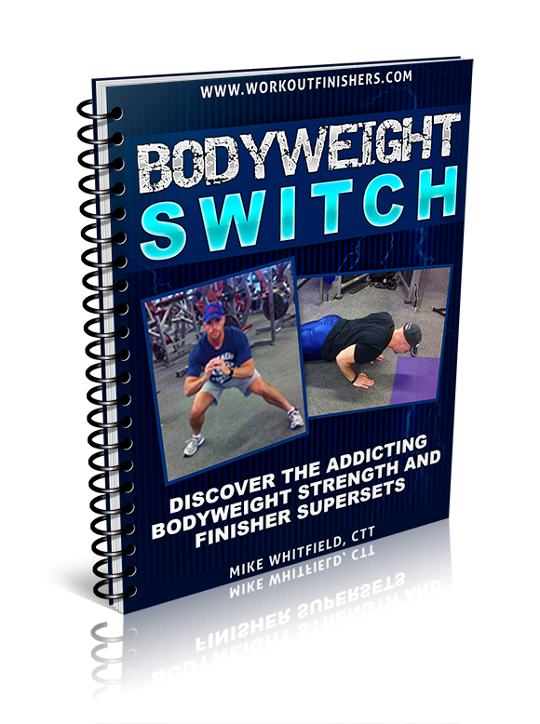

=> FREE Bodyweight Switch Program with Bodyweight Finishers

With Mike’s Bodyweight Finishers System and his Bodyweight Switch Metabolic Workouts Program, your belly fat doesn’t stand a chance. In fact, this is the perfect system if you enjoy your cheat meals but can’t break a plateau.

These short, but powerful bodyweight finishers work. After all, his clients have won $4,500 in contest money and not to mention – he’s lost 105 POUNDS HIMSELF.

Check out his before/after photos here

=> Short, but powerful Bodyweight Finishers and Mike’s before/after photos

Say goodbye to boring cardio (and even intervals) once and for all,

Your friend,

YOUR NAME

Day 2

Subjects:
Can You Out-train a Bad Diet?
#1 Method to Beat a Poor Diet
Finishers Trick to Out-train Carbs

The truth behind carbs is that you CAN still eat them and drop pounds of fat. In fact, you can drop MORE fat while STILL eating carbs.

Now obviously, a long term approach and overall health should be on your mind, but let’s face it. You have weekends. There’s football, family gatherings at restaurants, parties and more.

There are times when you do have to out-train some poor diet choices… but can you?... safely?

Maybe you’re really great during the week but when the weekends come, you just can’t avoid all the carbohydrates around you. You end up having pizza, ice cream and don’t forget the Saturday morning pancakes.

Whatever your favorite carbs might be, those “oops moments” call for more aggressive fat loss methods and you do have to step up your training.

But here’s the thing – you don’t want to work so hard to drop the extra fat you gained… just to gain it all back. You have to do it aggressively, sure… but safely.

And that’s exactly what I’ve found for you. My buddy Mike Whitfield, who enjoys pancakes more than any other fitness expert I’ve seen, uses these powerful metabolic finishers himself and with his clients.

And when they need to lose a lot of fat FAST, his trick is this… He will have his clients use these short, but powerful bodyweight finishers as conditioning on their off days for a week along with their workout program. Sure, they only last around 6 minutes, but the way they are designed will boost their metabolic rate 24 hours a day.

But these bodyweight finishers he uses are quite different than other bodyweight programs. He tracks exactly what works best and he is constantly tweaking his finishers to get the best results.

That’s why 6 of his clients have beat thousands of others and either won or placed in the Turbulence Training Transformation Contest.

And not only that, but his workouts with his clients are only 30 minutes! In fact, he is GIVING AWAY his new bodyweight program, “The Bodyweight Dirty 30”. These are powerful, but effective ZERO-EQUIPMENT 30-minute metabolic workouts you can do in the comfort of your own home.

Yep – these workouts are FREE.

And you get it when you grab his brand new Bodyweight Finishers program for just $20… that’s just 51 cents for each bodyweight finisher workout.

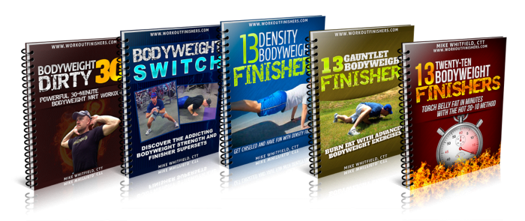

=> FREE 30-minute Bodyweight Workouts and 39 BW Finishers

Mike has inspired so many people with these unique finishers that one of his clients lost 9 pounds in just one week, even after a weekend binge.

Look I want this for you, too. You CAN eat carbs and “slip up” without falling off track. Mike used to weigh 300 pounds himself and knows what it is like to eat and feel guilty.

THESE finishers will give you the wiggle room you’ve been looking for in your diet.

And you can give yourself the freedom you deserve and be set free of your restrictive diet once and for all, if you start TODAY.

And just to be clear – these finishers WILL allow you to keep your lean, sexy muscle while stripping off stubborn fat… but they do take HARD work.

Mike uses a variety of methods with his finishers including the density method, the brutal, but effective gauntlet method, and of course his infamous 20-10 method.

The first method is his clients’ favorite – the density method. Here is one of his density finishers here:

Do the following circuit as many times as possible in 5 minutes, resting only when needed:

Jump Squat (5)
Triple Stop Pushup (5)
Total Body Extension (10)

The second method is the gauntlet approach, in which you have a very effective exercise repeated within a circuit with “active recovery” in between. It will bring you to the border of insanity, but highly effective.

And finally, there is the 20-10 approach. This one is very taxing on belly fat, and your metabolism gets revved up all day. Sometimes he uses a 20-rep exercise followed by a 10-rep exercise, and then there are times when he uses an exercise for 20 seconds followed by 10 seconds of rest for a certain amount of rounds.

You’ve probably heard of doing a 20-10 method before, but not like these finishers.

It is these finishers that allow his clients to eat MORE carbs and still drop pounds of fat week after week, even with 30-minute workouts!

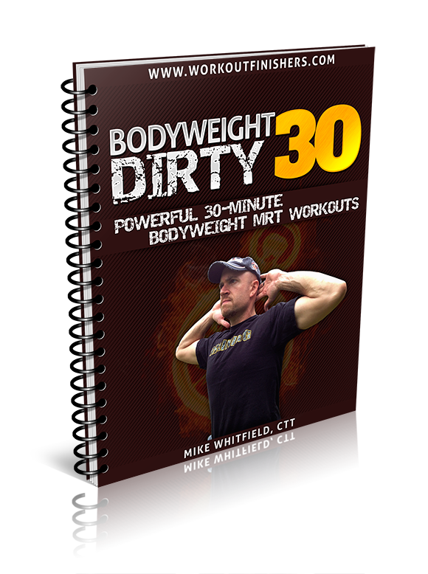
Now, there is a catch. His Bodyweight Dirty 30 program is not for sale. It’s only available THIS WEEK at the link below. Mike is giving it away for FREE with his brand new Bodyweight Finishers system.

==> Bodyweight Dirty 30 (THIS WEEK ONLY)

After this week, the Bodyweight Dirty 30 expires

But you can get it FREE when you pick up the brand new Bodyweight Finishers System for just $20 this week only!

==> Bodyweight Dirty 30 PLUS 39 Bodyweight Finishers

This is a shocking offer. The Bodyweight Dirty 30 is alone worth the small investment, but with this offer, you get a total of 5 Bodyweight programs!

Enjoy your carbs and lose fat, too with these finishers,

YOUR NAME
Day 3

Subjects:
The Hottest Workout Fix (sample inside)
Addicting Workout Secret (sample finisher inside)

Bodyweight workouts are BORING. At least, that’s what most people think.

People love bodyweight workouts because they give you that lean, athletic look and they can be done anywhere.

But the problem with most bodyweight workouts is that they can be really boring. Sure, you would have good intentions of using a bodyweight workout, but who wants to do the same 3 sets of 10 approach with plain pushups and bodyweight squats?

Thankfully, there is someone like Mike Whitfield, who thinks “outside the box” with his unique but effective bodyweight finishers that you can add to ANY workout to help you chisel that lean, athletic look without the boring same old bodyweight routines.

Here is a bodyweight finisher he used with one of his clients that won $1,000 in transformation contest money and got first place…

Get all 39 Bodyweight Finishers here for just $20 <==

The Fab 5 Bodyweight Finisher

Do the following circuit as many times as possible in 5 minutes, resting only when needed. Use a fast tempo on all exercises (but with good form):

Low Box Jumps or Total Body Extension (if you don’t have a box) (5)
Decline Close-Grip Pushups (5)
Prisoner Sumo Squat (5)
Double Burpee (5)
Skater Hops (5/side)

==> 39 BW Finishers + 2 BW Metabolic Workouts <== This week only

Try that finisher, then read the shocking study on that page on how a 4-minute trick is more powerful than 30 minutes of cardio for burning more fat…

… yes, a 4-minute trick!

After all, you could use more time, right? We all can.

There’s more crazy and unique finishers you can use with any workout with ZERO equipment.

And today, you not only get all 39 finishers for just $20, but he’s also giving away two ZERO EQUIPMENT Bodyweight Metabolic Resistance Training workout programs…

… yes, 8 full weeks of ZERO EQUIPMENT workouts for FREE.

39 Zero Equipment Finishers and 8 Weeks of Workouts <--- VIP invitation

Enjoy that challenging finisher,
YOUR Name

Day 4

Subjects:
Weird 4-Minute Trick Burns More Fat (time sensitive)
Your Bodyweight Workouts Gift (link expires)
FREE Metabolic Bodyweight Workouts (expires)
Friendly Reminder (this page goes down today)

Did you know that every year, there are thousands of people just like YOU that start a fitness program and end up GAINING weight?

That’s because they are doing what everyone else is doing – and that’s the world’s most popular exercise – cardio.

You saw earlier this week where this one 4-minute trick is more powerful and effective than 30 minutes of steady state cardio when it comes to fat loss. Yet, people still hit the treadmills and ellipticals and try to sweat their way to losing the fat they gained after a weekend binge.

But what can you do to solve this?

I’ve been showing you all week how powerful these short, but effective bodyweight finishers can be on your fat loss (even when you get off your diet).

These finishers have been proven by my friend Mike Whitfield’s clients after winning $4,500 in transformation money, including Philip, who lost 34 pounds in just 12 weeks. In fact, one of his clients lost 9 pounds in just 7 days.

By the way, Mike used these finishers to polish off 105 pounds of fat himself.

Mike shows how these finishers work on this page right here:

=> Shocking study PROVES 4-minute bodyweight finishers are better than cardio

And when you head to that page you’ll also see it’s the LAST DAY to take advantage of not only getting 39 fat-torching finishers for just $20, but also 8 weeks of zero equipment metabolic workouts for FREE.

I’ve never seen anything like this. You can plug these bodyweight finishers with YOUR favorite program to burn more fat and they are PROVEN to work. And you will get 8 weeks of bodyweight metabolic workouts including:

Bodyweight Switch – the addicting strength and finisher superset system

Bodyweight Dirty 30 – 30-minute metabolic workouts that use a combination of metabolic resistance training, metabolic conditioning and metabolic finishers, all without ANY equipment.
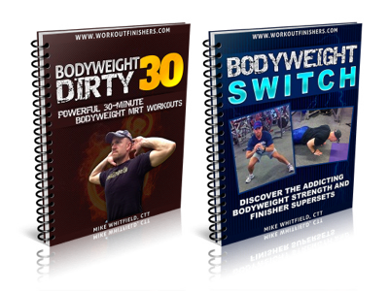

But after today, these bonuses go away.

==> Bodyweight Finishers PLUS 8 Weeks of BW Worktous for $20 (EXPIRES TODAY)

Finally, there’s a bodyweight system that you can use with YOUR favorite workouts. These workout grand finales will give you that lean, athletic look you’ve been looking for… all with ZERO EQUIPMENT.

The bad news?... now you have NO excuse for missing workouts due to lack of time or equipment.

Get all 39 Bodyweight Finishers PLUS 8 weeks of Bodyweight workouts for just $20… but this offer expires TODAY.

==> 39 Bodyweight Finishers PLUS Bonuses for just $20 (LAST CHANCE)

Enjoy these addicting finishers,
YOUR NAME

